

**SOFTWARE REQUIREMENT SPECIFICATION (SRS) SIGN-OFF**

**Authorization Memorandum**

This form is to sign-off completion of the Requirement Phase for **CAMPUS MANAGEMENT SOFTWARE AT WORLD SKILL CENTER (WSC).**

World Skill Centre (WSC) acknowledges receipt of the deliverables as part of the Requirement Phase through the submission of this document.

|  |  |
| --- | --- |
| **MODULE NAME** | **Faculty Workload** |

| **VERSION HISTORY** | | | |
| --- | --- | --- | --- |
| **Version** | **Author** | **Date** | **Changes** |
|  |  |  |  |
|  |  |  |  |

**WSC AUTHORITY NAME AND**  **SIGNATURE**

**SOUL AUTHORITY NAME AND**  **SIGNATURE**

Pages 1 of 11



**Sustainable Outreach And Universal**

**Leadership (SOUL) Limited**

**Software Requirement Specification (SRS)**

**Of**

**Faculty Workload**

For Implementation of

**Campus Management Software**

at

**World Skill Center (WSC)**

**Content**

A. Abstract 3

B. Introduction 3

C. Definition, Acronyms and Abbreviations 3

D. Overview of the Document 3

E. Scope 4

F. List of Screens and their descriptions 4

G. Process Definition and Requirements 5

1. Faculty Workload 5

Description: 5

Faculty Work Assignment 5

Instructor Workload Report 5

Screens 6

1.1 Faculty Work Assignment 6

General Description 6

Screenshot 6

Field List 6

Note : 8

User: Roles & Permission 8

1.2 Instructor Workload Report 8

General Description 8

Screenshot 9

Note : 9

User: Roles & Permission 9

# Abstract

Software Requirements Gathering is one of the first phases of system development. This phase results in the Software Requirements Specification (SRS) document, which must contain a complete, concise, high-quality description of the system being considered.

# Introduction

The World Skill Center (WSC) is a premier advanced skill training institute established by the Government of Odisha, Skill Development and Technical Education Department, through the Odisha Skill Development Authority (OSDA). The WSC will impart advanced skill training in eight trades from engineering and service sectors. WSC caters primarily to induct the best talent from ITIs and Polytechnics and train them to become globally employable in emerging areas such as "Industry 4.0". WSC is housed in a state-of-the-art, 18-storey, air-conditioned building with nearly half a million square feet of space in the heart of capital city of Bhubaneswar.

With the Implementation of campus management software for WSC the goal is to streamline the operations and functions of the campus by integrating various processes, such as admissions, course registration, academic progress tracking, and financial management, HRMS, Procurement and Inventory management, etc into a unified system. The implementation also aims at providing a user-friendly interface for all stakeholders, making it easier for them to access the necessary information and complete their tasks with ease. The modules to be covered during the implementation of the software includes:

|  |  |
| --- | --- |
| Students Management Modules | Infrastructure Management |
| Academic System | Finance and Accounting System |
| Procurement & Inventory Management | Training and Placement |
| Human Resources Management System | Application Integration |

# Definition, Acronyms and Abbreviations

The following table explains the terms and abbreviations used in the document:

|  |  |
| --- | --- |
| **Abbreviation** | **Description** |
| SRS | Software Requirements Specification |
| R | Rename - When a field is Renamed |
| N | New - When a New field is Added |
| D | Delete - When an Existing field is Deleted |
| NA | Not Applicable |

# Overview of the Document

This requirement document provides a detailed overview of the functional requirements of a project. It serves as a communication tool between stakeholders, including developers, project managers, and end-users. The purpose of this requirement document is to define and document the project's objectives, scope, and expectations, and to ensure that all stakeholders have a clear understanding of what the project entails.

The Software Requirements Specification (SRS) is a comprehensive document that outlines the functional and non-functional requirements for the development of the **"Faculty Workload"** system. This system aims to automate and streamline the workload management process for faculty members in an educational institution.

# Scope

The "Faculty Workload" system is designed to assist educational institutions in managing and allocating faculty workload efficiently. It covers various aspects, such as :

* course assignments
* research projects
* administrative tasks and other responsibilities

The system aims to optimize the workload distribution process, ensure fairness, enhance productivity, and improve overall efficiency.

Following functionalities are covered in this SRS document:

* **Faculty workload (specific functionalities and features that the "Faculty Workload" system should possess. It covers various use cases, such as faculty assignment management, workload distribution, reporting, and administrative tasks. Each requirement is described in detail, including inputs, outputs, and system responses.) ** ▪

# List of Screens and their descriptions

The following screens are present in Employee Life Cycle sub module :

|  |  |  |
| --- | --- | --- |
| **Sl no** | **Application** **Screen Name** | **Description** |
| 1 | Faculty Work Assignment | The faculty work assignment screen is a user interface within an educational institution's system or software that allows administrators or authorized personnel to assign tasks and responsibilities to faculty members. |
| 2 | Instructor Workload Report | On the Instructor screen, faculty members will have access to their workload report, providing a comprehensive overview of their assigned tasks and responsibilities. |

# Process Definition and Requirements

## Faculty Workload

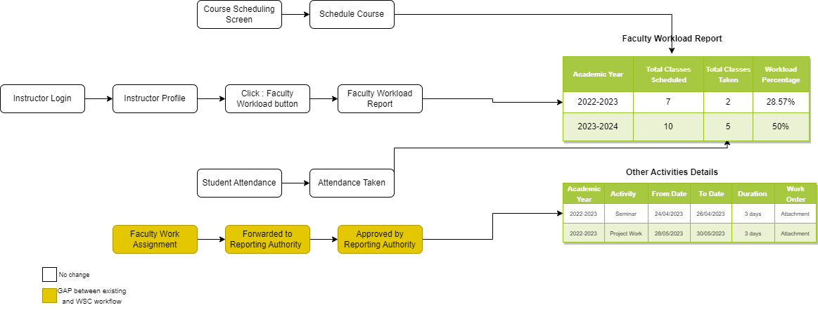

Figure 1 : Faculty Workload Flow

**Description:**

**Faculty Work Assignment**

The faculty workload assignment screen is a user interface within an educational institution's system or software that allows administrators or authorized personnel to manage and allocate workload to faculty members.

This section allows administrators to input specific details about the task or assignment, including the title, description, objectives, deadlines, and any additional instructions or requirements.

**Instructor Workload Report**

An instructor workload report is a document or summary that provides an overview of the workload and responsibilities of a specific instructor within an educational institution. It presents information about the tasks, courses, and other duties assigned to the instructor, helping to track and evaluate their workload.

**Screens**

### Faculty Work Assignment

**General Description**

The following table describe overall information about this screen:

|  |  |
| --- | --- |
| **Description** | 1. The faculty work assignment screen is a user interface within an educational institution's system or software that allows administrators or authorized personnel to assign tasks and responsibilities to faculty members. |
| **Navigation** | Home >HRMS>Faculty Work Assignment |
| **Pre-requisites** | The system should have records in the following screen   1. Employee |
| **Existing Screen Name** | NA |
| **New Screen Name** | Faculty Work Assignment |

**Screenshot**

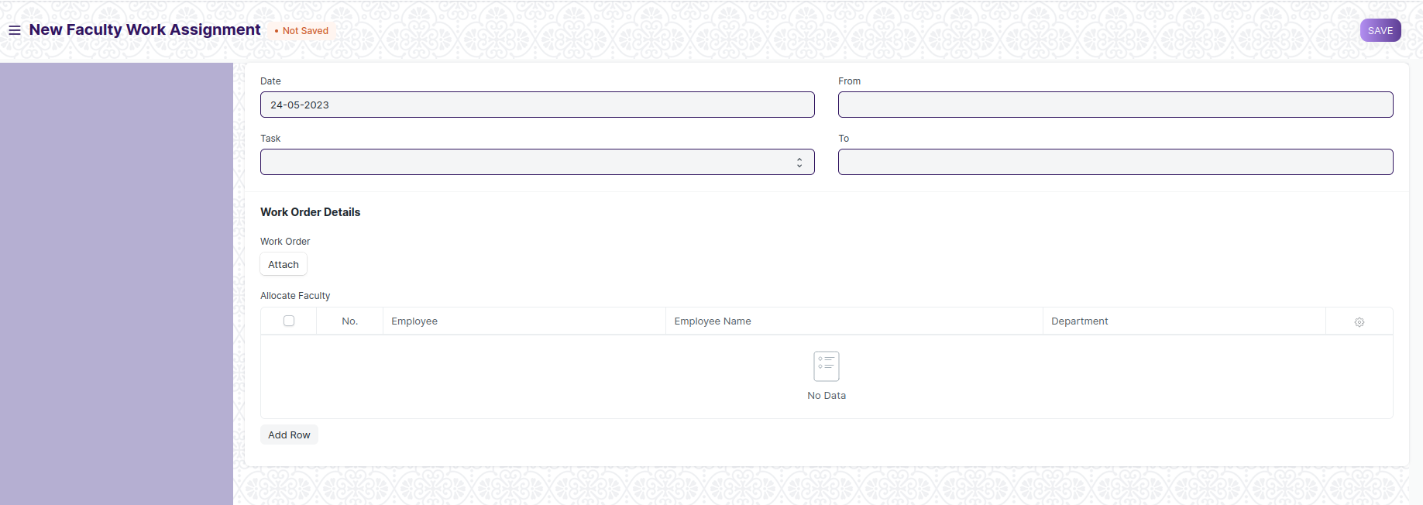

Figure 2 : Faculty Work Assignment Screen

**Field List**

The following table describes the UI fields present in this screen :

|  |  |  |  |  |  |  |
| --- | --- | --- | --- | --- | --- | --- |
| **ID** | **Label** | **Type** | **Mandatory** | **Validation / Action** | **Remarks** | **R= Rename**  **N= New**  **D= Delete** |
| 1 | Date | Date | Yes | By default it will take current date. |  | N |
| 2 | Task | Dropdown | Yes | Options :   * Research Projects * Professional Development * Task Rotation * Community Engagement * Other Scholarly * Mentoring * Curriculum Development * Publication Reviewing * Academic Writing * Student Research Supervision * Professional Consultation * Educational Outreach * External Examiner Roles * Industry Guest Lectures * Academic Program Development * Teaching Workshops * Student Support and Advising * Exam Paper Evaluation * Exam Proctoring * Conference Presentation * Industry Collaboration * Invigilator * Accreditation and Quality Assurance * Faculty Recruitment * International Education Programs |  | N |
| 3 | From | Date |  |  |  | N |
| 4 | To | Date |  |  |  | N |
| 5 | Work Order | Attachment |  | User will attach the work order |  | N |
| 6 | Allocate Faculty | Table |  | Description of table is given below |  | N |

|  |  |  |  |  |  |  |
| --- | --- | --- | --- | --- | --- | --- |
| **Assign Faculty** | | | | | | |
| **ID** | **Label** | **Type** | **Mandatory** | **Validation/ Action** | **Remarks** | **R = Rename**  **N= New**  **D= Delete** |
| 1 | Faculty | Link |  | Link Field to Instructor Master Screen |  | **N** |
| 2 | Faculty Name | Text |  | Auto Fetch on selection of Faculty |  | **N** |
| 3 | Department | Text |  | Auto Fetch on selection of Faculty |  | **N** |

**Note :**

* Other Task assignment will be initiated .
* After submission of form, it will be forwarded to the Reporting authority for approval.
* After approval of reporting authority , it will be forwarded to the department head for the approval.
* Once it is approved , the Activity details will be visualized in the Instructor workload Report, which is present in the instructor profile.

**User: Roles & Permission**

The following table describes the users and their roles and permissions for the screens :

|  |  |  |  |  |  |  |  |  |  |
| --- | --- | --- | --- | --- | --- | --- | --- | --- | --- |
| **ID** | **Role** | **Select** | **Read** | **Write** | **Create** | **Delete** | **Submit** | **Cancel** | **Amend** |
| 1 | HR Admin/Director Admin | Yes | Yes | Yes | Yes | Yes | Yes | Yes | Yes |
| 2 | HR Manager/CS | No | Yes | Yes | Yes | No | Yes | Yes | Yes |
| 3 | Reporting Authority | Yes | Yes | Yes | No | No | Yes | No | No |
| 4 | Employee | No | Yes | No | No | No | No | No | No |

### Instructor Workload Report

**General Description**

The following table describes overall information about this screen:

|  |  |
| --- | --- |
| **Description** | 1. The instructor workload report may also include details about both teaching and non-teaching activities or responsibilities undertaken by the instructor. 2. It provides a comprehensive picture of the instructor's workload and distribution of their time and effort across various academic and non-academic tasks. |
| **Navigation** | Home >SLCM>Admission>Instructor |
| **Pre-requisites** | The system should have records in the following screen   1. Employee 2. Instructor |
| **Existing Screen Name** | Instructor Workload Report |
| **New Screen Name** | No change |

**Screenshot**

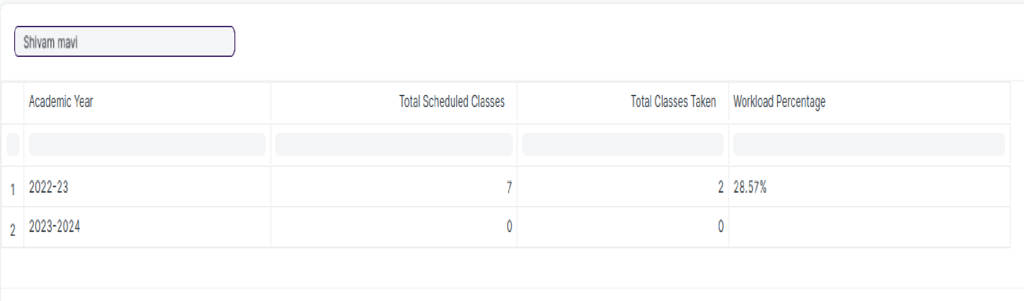

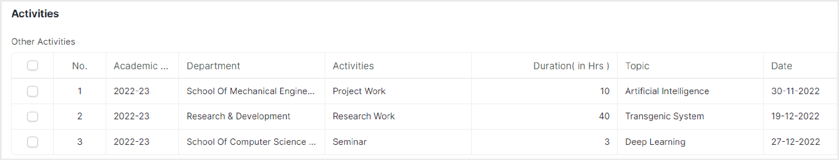

Figure 3: Instructor Workload Report

Description :

* The instructor workload report provides a comprehensive snapshot of an instructor's workload, encompassing various aspects.
* It includes the total number of classes scheduled and taken in each academic year, enabling the calculation of workload percentage based on these values.
* Additionally, the report visualizes the details of non-teaching activities assigned to the instructor, which are sourced from work orders.
* This integration allows for a holistic view of the instructor's workload, combining teaching responsibilities with other assigned tasks.
* The report also facilitates academic year comparisons to identify workload trends and patterns over time.
* Overall, the instructor workload report serves as a valuable tool for workload management, resource allocation, and decision-making within the educational institution.

**Note :**

Accessing the instructor workload report :

* From the instructor screen, click on the instructor's name to open their profile, and then select the "Workload Report" button.

**User: Roles & Permission**

|  |  |  |  |  |  |  |  |  |  |
| --- | --- | --- | --- | --- | --- | --- | --- | --- | --- |
| **ID** | **Role** | **Select** | **Read** | **Write** | **Create** | **Delete** | **Submit** | **Cancel** | **Amend** |
| 1 | HR Admin/Director Admin | Yes | Yes | No | No | No | NA | NA | NA |
| 2 | Department Head | Yes | Read | No | No | No | NA | NA | NA |
| 3 | Instructor | No | Yes | No | No | No | NA | NA | NA |